

MASTER OF COMPUTER and INFORMATION SCIENCES

COMP 809
Data Mining & Machine Learning

ASSIGNMENT ONE

Semester 1, 2015

Due: Wednesday 8 April at midnight.

Weighting: 30%

Submission: A soft copy needs to be submitted through Turnitin (a link for this purpose will be set up in AUTonline).
AIMS

The Aim of this assignment is two-fold. Firstly, in Part A, you are required to conduct a literature review of data mining applications in Industry, and will thus provide you with a further insight into the ways that data mining is used in practice.

Part A

Your survey should cover three different application areas (ensure that these are from different domains – e.g. banking, retail, health, economics, etc). The survey is intended to assist you in establishing a suitable framework (application area, tools, algorithms) on which your mining project will be based.

DELIVERABLES

The results of your survey must be presented in report form and must include for each application area the following:

- Background information on the organisation and the target application (e.g. detecting credit card fraud, etc)
- A description of the data used in the mining exercise
- A description of the mining tools (i.e. algorithms/mining software) used, together with an identification (no details required) of the mining algorithms that they employ
- Discussion of either potential or actual outcomes and benefits to the organisation that resulted from the mining exercise
- Appropriate use of references

The total length of your report for Part A is expected to be in the range of 2000-3000 words. The criteria that will be used for assessment in Part A is as follows:

Criterion | Mark
Overall Quality of Presentation | 06
Background | 4*3=12
Tools and Mining algorithms | 4*3=12
Outcomes and Benefits | 5*3=15
References | 05

Part B

This part gives you an opportunity to solve two real-word data mining problems using the Weka machine learning workbench. In the two questions given below justification of your answers carries a high proportion (50%) of the marks awarded.

- Application Area 1 (dataset for this is CarEvaluation.csv; dataset description is in CarEvaluation.txt)

This application is concerned with rating cars on a number of factors. The dataset contains 1728 cars, each of which is rated according into one of four categories or classes.

You are required to build a model using the J48 Decision Tree learner and answer the following questions based on the model built. In building the model, use the 10 fold cross validation option for testing.

Your answers below need to be supported by suitable evidence, wherever appropriate. Some examples of suitable evidence are the Decision Trees, and Confusion Matrices.

- Using the J48 Decision Tree with all parameters set at default values. From the model generated rank the 3 most important features. [3 marks]

- Alter one of the J48 parameters and obtain an overall classification value that is at least 96%.

- Which parameter did you adjust? [2 marks]
- Why did the new setting of this parameter improve accuracy?
[4 marks]
- Do you expect that manipulating the parameter in the same way will improve accuracy for other types of datasets? Justify your answer. [4 marks]

- It is possible to reduce the number of decision paths to 30 whilst ensuring that accuracy is over 95%.
  - Which parameter achieves this result? [2 marks]
  - What is the role of this parameter? (do not simply use Weka’s description here; do your own research and [4 marks]

- It is possible to reduce the number of decision paths further to 20 while ensuring that accuracy is around the 91% mark.
  - Which parameter (different from the one identified in c) above) is responsible for this? [2 marks]
  - What is the role of this parameter? [4 marks]

- Examine the Confusion Matrix carefully. You will notice that the success rate of predictions for the “good” and “vgood” classes for the model produced in d) above is much lesser than for the other two classes.
  - Why do you think this happens? [3 marks]
  - Use cost sensitive classification with the J48 algorithm and all parameter settings as used in d) above to produce a model that has at least 90% success rate on all 4 classes. Give the cost sensitive matrix that achieves this result. [5 marks]

- Application Area 2 (dataset for this is Diabetes.arff)

This application is from the Medical domain and is concerned with predictions of diabetes for a collection of individuals from whom relevant medical data has been obtained. The objective is to predict whether a given individual will suffer from diabetes (tested positive) or not (tested negative) in a year’s time from gathering the data.

For this dataset you will use both the J48 and Naïve Bayes algorithms to mine the data. For both methods use the 10 fold cross validation option for testing.
- As with dataset 1, use an appropriate method of feature selection to identify the most significant features. State method used and list the features produced.
Search Method: weka.attributeSelection.LinearForwardSelection -D 0 -N 5 -I -K 50 -T 0
Selected attributes: 2,6,7,8 : 4
plas
mass
pedi
age

- Run the Naïve Bayes algorithm with the UseSupervisedDiscretion option set to “True”. Use the count table produced by the Naïve Bayes model to produce a probability model table similar to the one discussed in class. Use this probability table to identify the top 3 (feature, value) pairs that predict the presence of heart disease. Show all working. [8 marks]

The top 3 feature value pairs are:
  - mass = '(27.85-inf)'
  - age = '(28.5-inf)'
  - preg = '(-inf-6.5]'
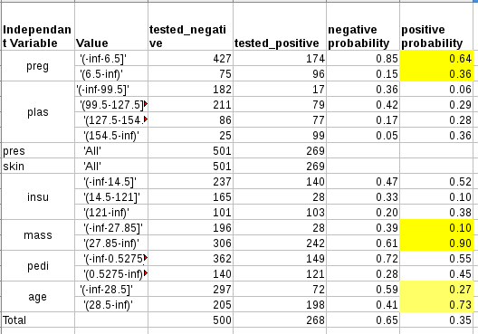
- Now run the J48 algorithm and compare the list produced in 1 above with the top 3 features produced by the J48 Decision tree model. Identify similarities and differences. Discuss any differences. [5 marks]
The top 3 features produced by the J48 Decision tree are:
plas, mass, age
The top 4 features in step 1 are:
plas, mass, pedi, age

